**Laboratory System**

**Challenge**

Client wants to develop window based software for portfolio of products, services and support to each and every one of customers satisfying the many needs of the users across the global laboratory research, diagnostics and molecular biology markets. We have taken the samples for report and derived the result in the graphical manner along with consider parameters The software has different stages such as analysis, connection ,profile, run, setting, spectra, temperature.

The challenging part of software is data read for firmware and plot the data in every time interval and represent it in graphical manner which consider parameters like temperature, minimum, maximum , threshold limit.

**Solution**

Shaligram Infotech has developed with utilizing the latest technology as a Windows WPF with C#

Unique Features:

* Third party using Telerik For User Interface
* Responsive
* Reports For doctors
* User Friendly UI
* Security
* View Graphical Data

**Result**

Client has been successfully developed the automated robust software and enhance their business as well as saving the time.

* Window Application comes with client’s 100% requirement and has given then the high level of satisfaction.
* The window software was exactly looking at what the client wanted.
* Developer ensured 100% adherence to the client for requirem­­­­­­­­­ents.
* The client was very happy with the design and feature which we have provided to him.
* Analysis Screen

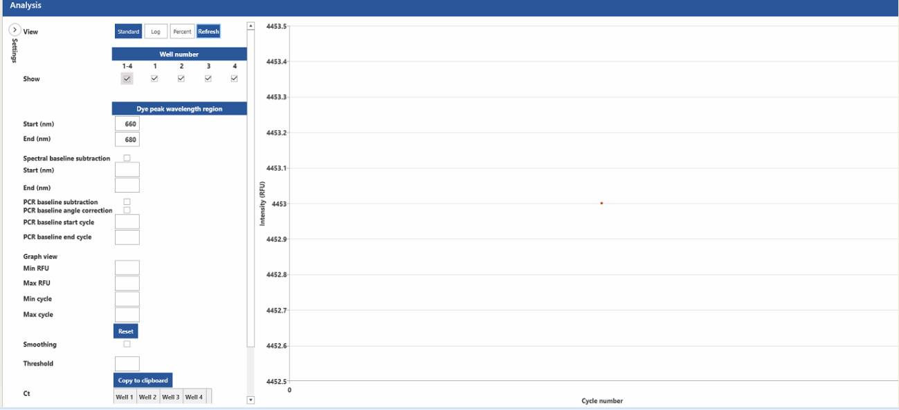

* Connection Screen

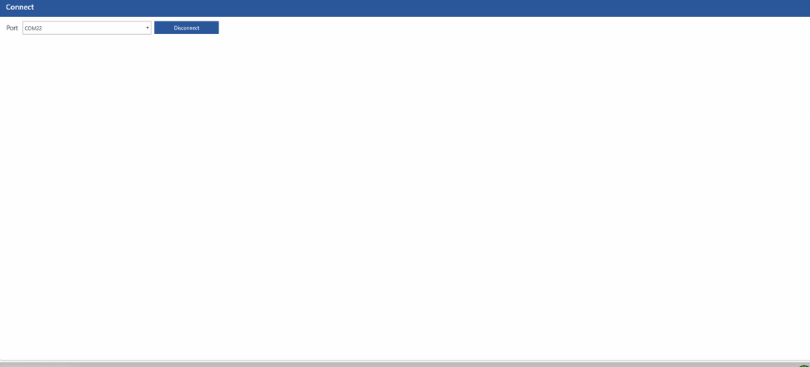

* Profile Screen

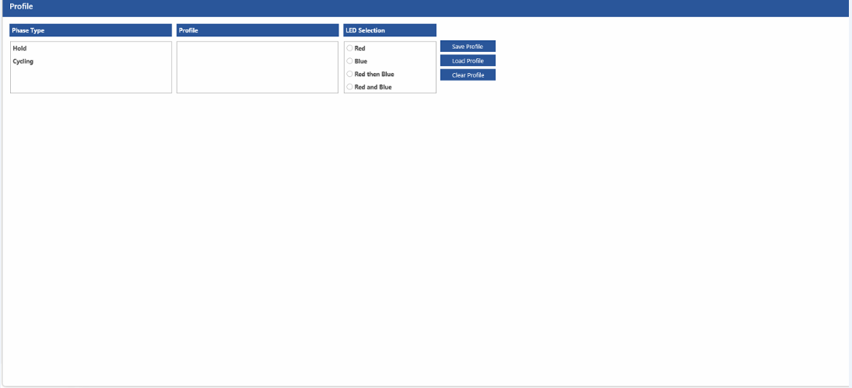

* Run Screen

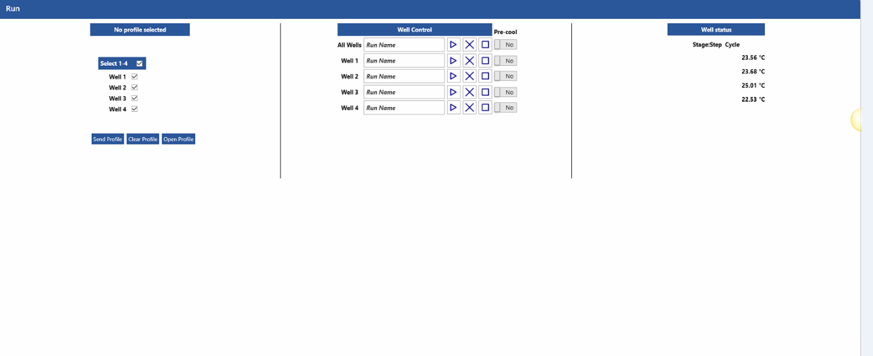

* Setting Screen

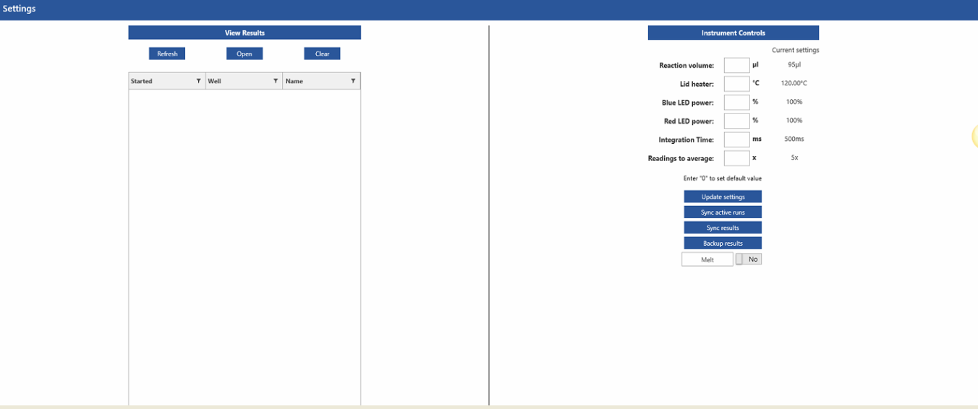

* Spectra Screen

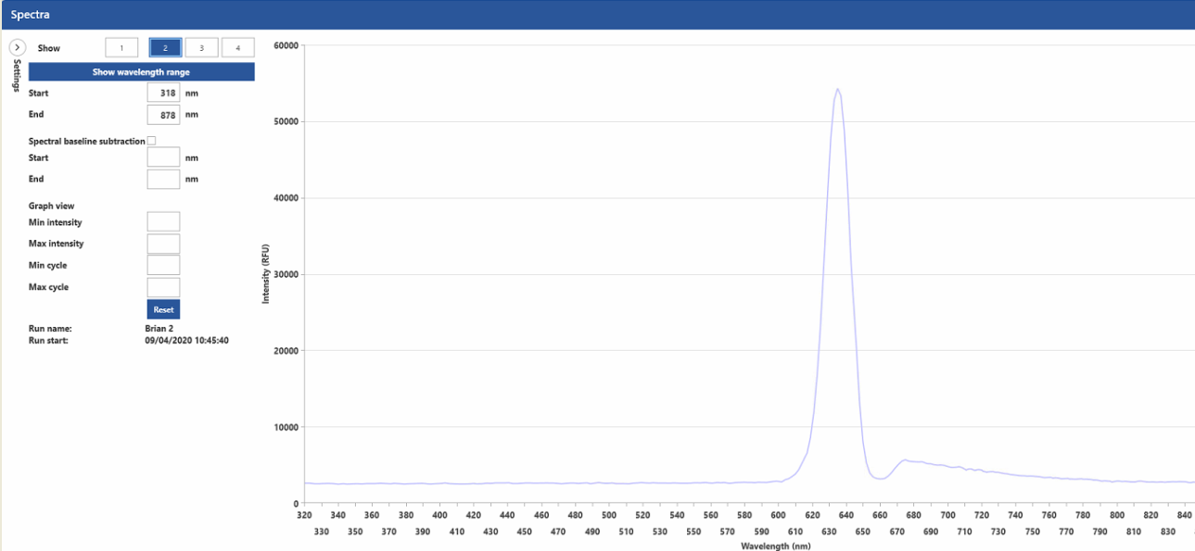

* Temperature Screen

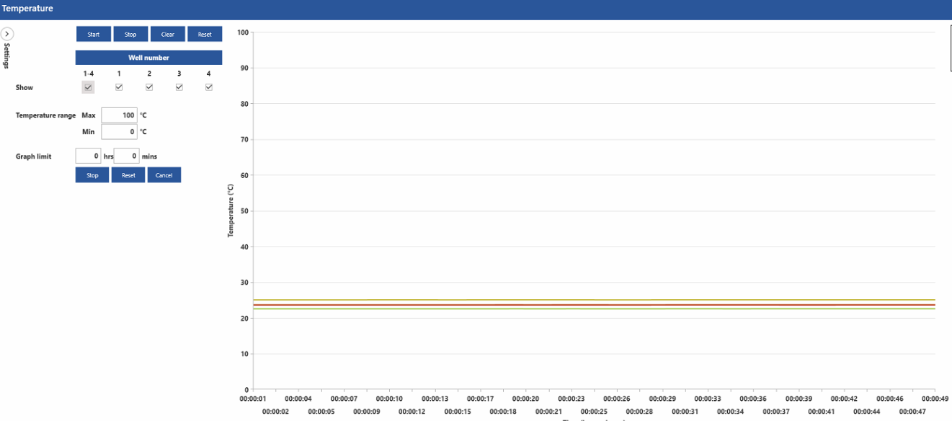

**Technology**

|  |  |
| --- | --- |
| Application Server | Window |
| Programming Language | WPF with C# |
| Database | MS SQL Server 2014 |
| Development Tool | Visual Studio |
| Third party components/applications | Telerik |

**Why Shaligram Infotech?**

* ISO 9001:2008 certified organization
* Successfully executed more than 400 Projects on ASP.NET technology.
* Expertise in Microsoft Technologies Development (.NET, ASP.NET MVC, WPF, UWP, SQL, SharePoint, BizTalk)
* 5 Microsoft Certified Developers.
* Expertise in Mobile Technology like iOS, Android, Windows smart phones.
* Expertise in PHP Development with Successful delivery of more than 400 projects.
* Expertise in different Frameworks such as Zend, Code ignitor and open sources such as WordPress, Joomla, Magento, etc.
* Consulting led Solutions - All services are bundled into point solutions that address critical IT needs for Industry sectors
* Focus on Innovation - Shaligram Infotech continues to focus on driving innovation and makes significant investments in developing IP assets, accelerators etc.
* "Customer First" culture - Agility and flexibility with the willingness to adapt to client's context and the drive to show excellence have been instrumental in our long term relationships with our clients